**Instruction Document for the Manual annotations GUI**

# Installation

To install the GUI application go in the shared folder and double click in the “GUI_annotations” package:

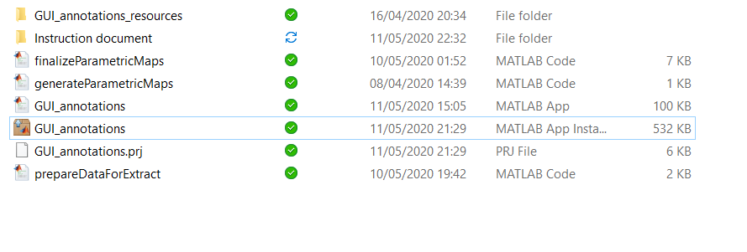

Once you click it, MATLAB will show a pop up:

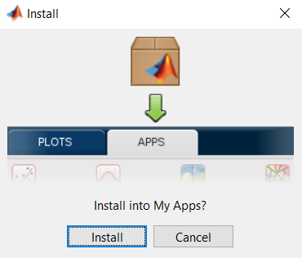

Click in the install button and the installation is complete.

# Open the GUI

## Open from MATLAB

After the installation is complete the GUI will appear in the APP tab in the top of the MATLAB menu:

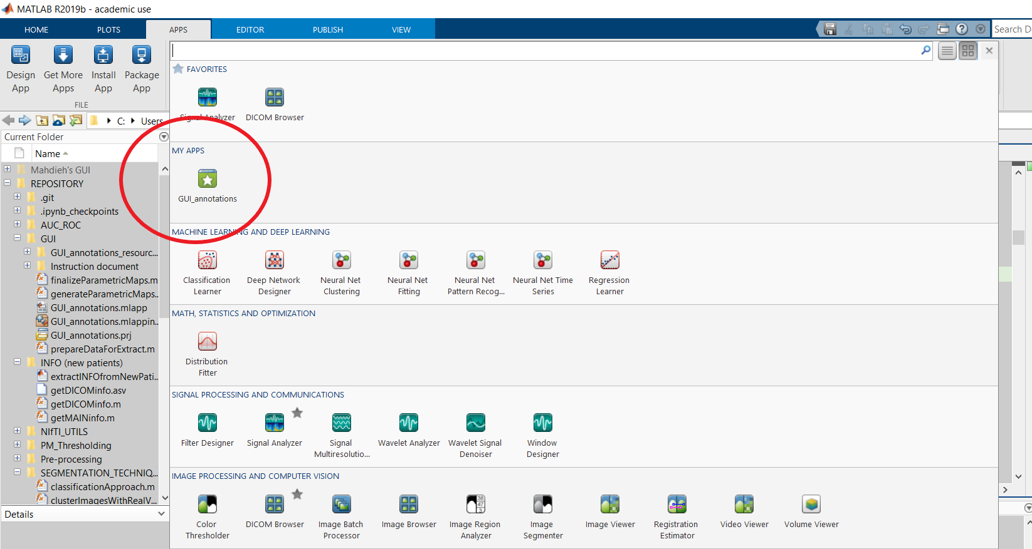

# **THE GUI APPLICATION**

Here is a brief summary of the GUI and its various tabs.

# **Parametric Maps TAB**

This is how the GUI looks like when you open it:

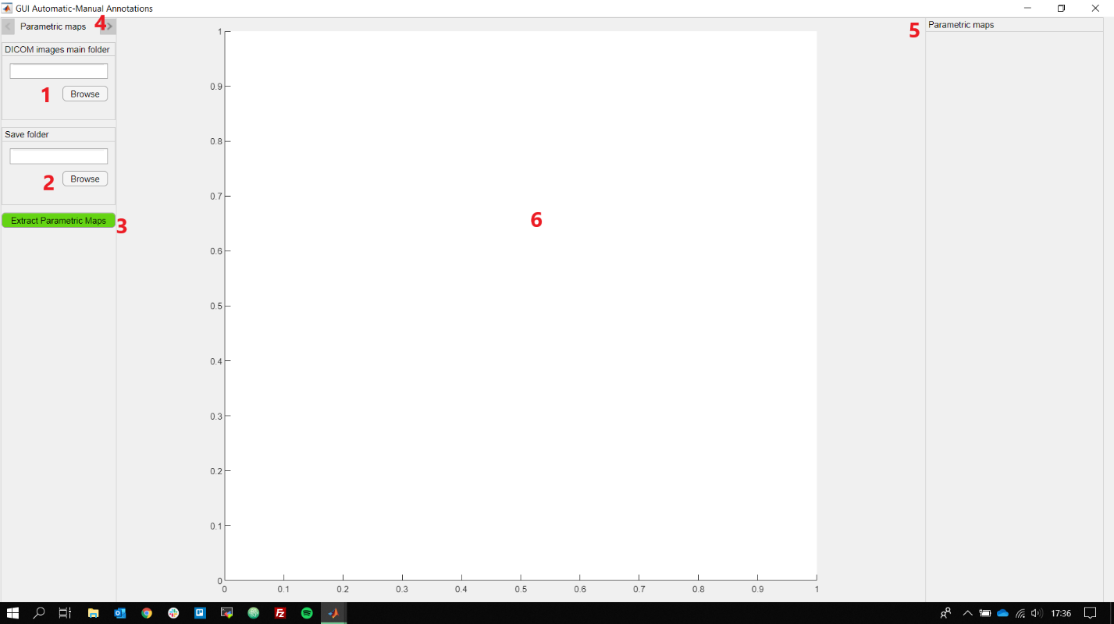

1. This text field MUST contains the folder with the patient images in DICOM format (i.e. the main folder of the hard drive containing “LVO/”, “Non-LVO/” and “Without vessel occlusion/”);
2. This text filed MUST contain the **MAIN** saving folder.
3. Once you inserted both the folder (DICOM and SAVE), you can click this button in order to start extracting the parametric maps from the DICOM folder **1** and save them in the MAIN saving folder **2** inside a subfolder called “Parametric_Maps”. It will also create a folder called “Workspace”, containing the workspace used in MATLAB (important to me 😊 ).
4. Extract **3** the parametric maps will create a folder for each patient inside the **MAIN** saving folder; **if you extract the parametric maps again the previous will be override!**
5. In this section, you can move between the various tabs: “Parametric Maps”, “Predictions”, and “Draw”.
6. This part will contain the different parametric maps for the selected patient and slice
7. This is the main section; it will contain a selected parametric map with the predicted annotations that can be edit or delete.

### After extracting the Parametric maps **3**

During the extraction of the PM, you will see a progress bar in the GUI, like this:

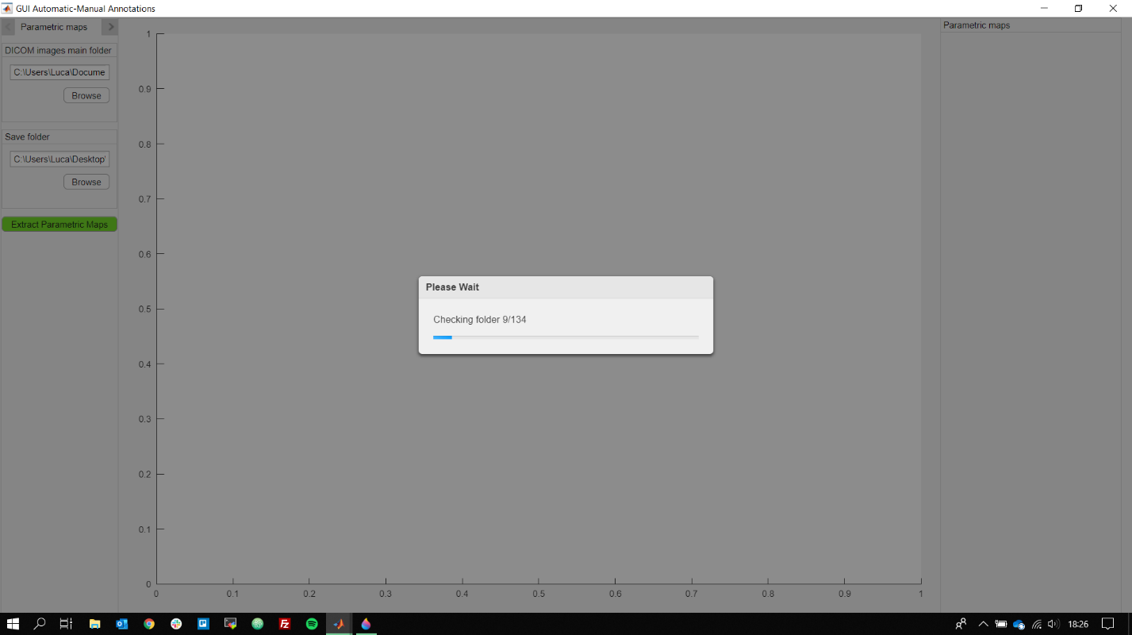

**It is not possible to stop the execution once it starts running.**

For each patient, the extraction and the prediction take on average 2 minutes depending on how many slices the patient brain is composed and how many times the parametric maps are taken for a single patient study.

At the end of the extraction, you will have inside you selected **MAIN** saved folder, a similar structure:

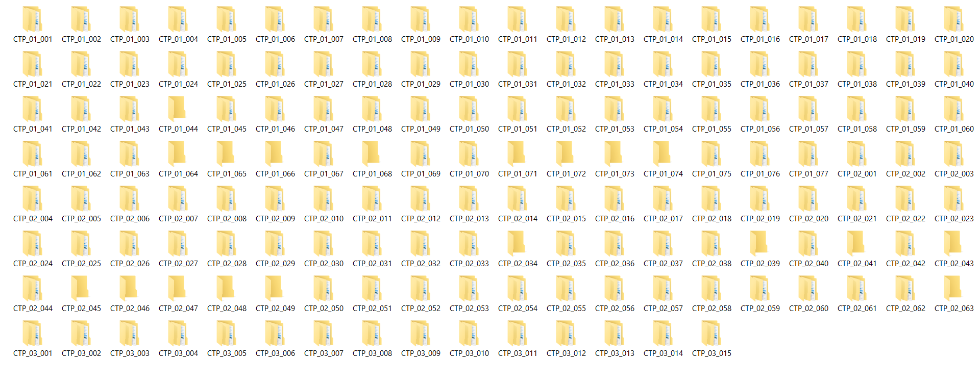

Each folder contains the studies of a patient, divided by the date (plus hour), as displayed in the following image. Most of the patients contain one single study, but some of them have multiple studies in it.

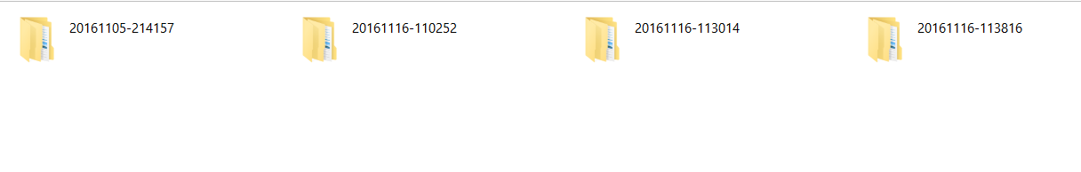

Each of these folders contain all the parametric maps generated at the same time (based on the information gathered in the DICOM header) plus two other folders (created after running the prediction for the specific patient).

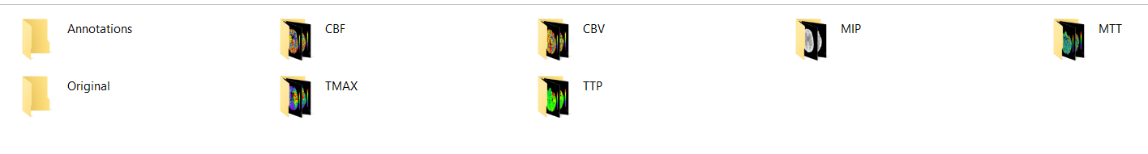

The folders MIP, CBF, CBV, TMAX, TTP, MTT contain the corresponding parametric maps for that day/hour. For same studies, all these parametric maps are not generated, so that is the reason why in some of the patient you might don’t see all of them.

# **Prediction TAB**

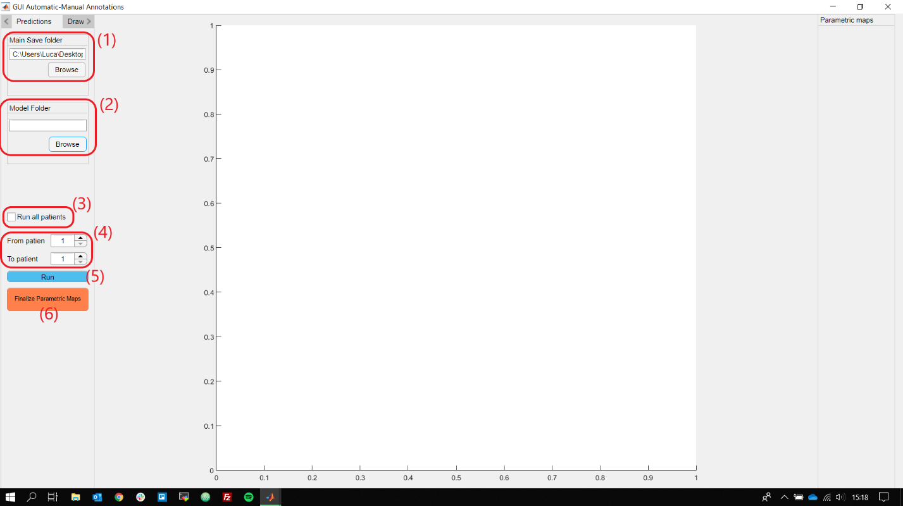

The image above shows the prediction tab and its components. This tab is used to predict the various infarcted region, based on some models, of the patients.

Field **(1)** represents the **main** save folder, it is the same variable as **2** in the previous tab (parametric maps).

The second part contains the model folder **(2)**, which is the one that contains the model used to predict the infarcted regions (provided by Luca).

Then, **(3)** and **(4)** gives you the possibility to choose which patient you want to run the prediction model.

If you check the field **(3)**, as the text suggests, the prediction will run for all the patients stored in the main save folder. Otherwise, if **(3)** is not checked, the GUI will control the fields in **(4)**: whit these fields you can select for which patient you want to predict the regions, based on **from/to** values.

The button **(5)** start the predictions for the selected patients (in **(3)** and **(4)**), with the model choose in field **(2)** and save them in the main save folder.

Button **(6)** is only used to create the **final** parametric maps of each patients: it is useful for me because it will create a ground truth image for each patient slice containing the brain and the infarcted regions (if present). It has nothing to do with the prediction, but it will be immensely helpful for the other projects. To understand, the image on the right is an example of the results from this button.

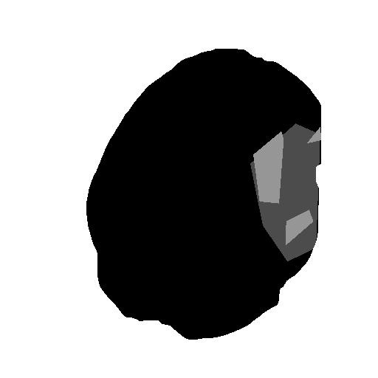

After you click the run button **(5)**, you cannot stop the execution, similarly as the extraction button (3) in the parametric maps tab, and a progress bar will appear to show you which patient is been analyzed at the moment:

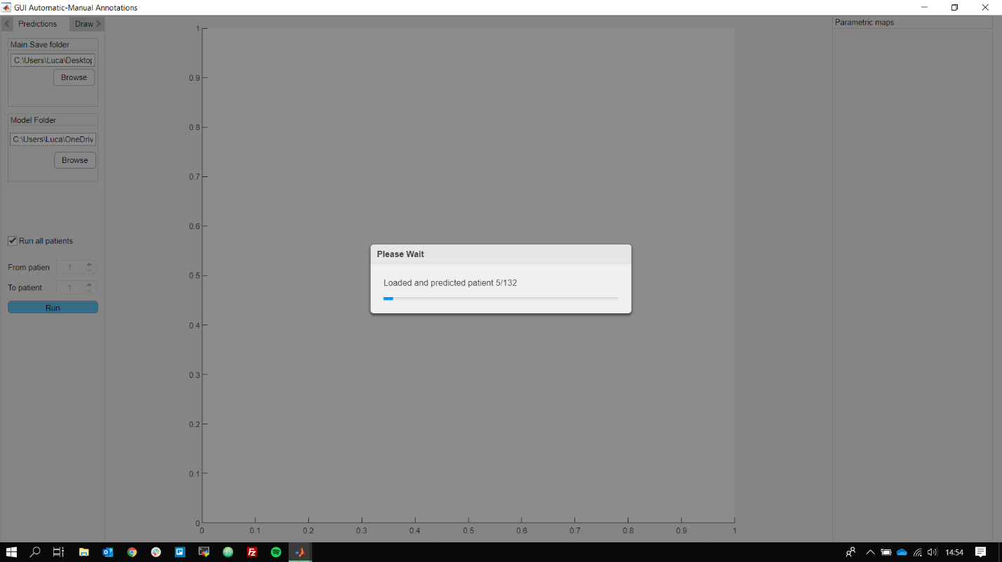

At the end of the prediction, you will have, for each of the patient analyzed, a similar structure inside their folder:

  
The parametric maps have been explained before, while the other two folders are generated when the run button **(5)** is finish:

* **Original:** it contains the annotations predicted by the models separated by the type of infarcted area.
* **Annotations:** normally it will contain empty images (= no annotations), but the folder is used to save and store the annotations created through the GUI.

# **Draw TAB**

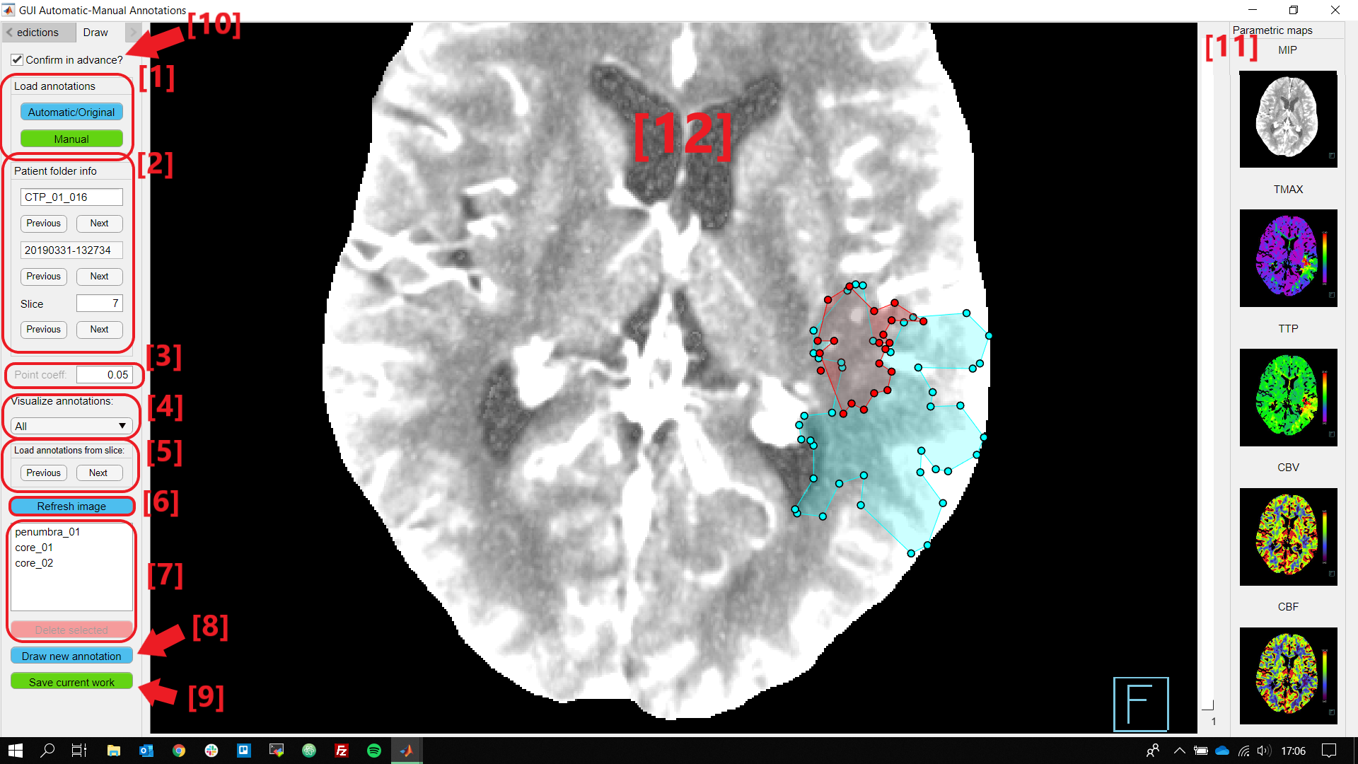

Here is the most important tab of the GUI: the draw tab.

There are a lot of components in this tab; here is a brief explanation for all of them:

* **[1]**: in this part there are two buttons that you can use to load the annotations:
  + **Automatic/Original**: this button loads the predictions of the infarcted regions made automatically (from the previous tab).
  + **Manual**: this button loads the annotations made manually.

The current setting is seen with a green color in the button, while the other with blue; in that image, the current setting is the “Manual”, since the button color is green, so the annotations that you are seeing in the main area **[12]** are manually created.

* **[2]**: this section shows the various information of the current slice and the patient folder:
  + The first part is the name of the patient folder (patient id),
  + The second is the date+hour folder
  + The last part tells the current slice of the patient.

All these components have two buttons: **Previous** & **Next**, which you can use to move to the next or the previous element (slice, patient folder or date folder). In alternative, you can directly edit the text field and press return to change the folder/slice/…

When you change one of these values or you click a Previous/Next button, a confirmation dialog will pop out asking if you really want to do this (just in case you have some unsaved work)

* **[3]**: this is a fundamental variable during the process: it is the point coefficient. Default value is 0.5; the values can be from 0.01 to 1, where a small value means less point per annotations and a large value means a lot of points for each annotation and more time consuming to load the figure. Normally I use a value between 0.02 and 0.1 to do changes in the annotations because otherwise there would be too many points to move.
* **[4]**: with this panel you can choose what to see in the main figure:
  + **All**: both the penumbra and core regions,
  + **Penumbra**: only the penumbra regions,
  + **Core**: only core regions.
* **[5]**: these two buttons are helpful if you want to load the annotations (infarcted regions) from a different slice, you can select the previous or the next.
* **[6]**: I noticed that sometimes, maybe if you have just finished a drawing of a region and then you want to zoom out or move to another part of the image, the commands are not responding. So, the best thing to do in these cases is to press this button to refresh the main image **[12]** with all the annotations (**even if they are not saved yet**).
* **[7]**: here is a list of all the infarcted regions **showed** in the figure now (if you change the value in [4], the list will update). The list shows the ID of the annotations (you need to put your mouse over one of them to check its ID).

If you select one of the element in the list, the red button beneath the list (**“delete selected”**) will be enable; if you click a alert will pop up asking for the confirmation and if you click “OK” the selected region will be deleted.

* **[8]**: This button allows you to draw a new annotations (region), once clicked a dialog will pop out where you can choose between a penumbra or core region to draw. Once you have selected it, you can start drawing the annotation in the main figure.
* **[9]**: This button saves the current annotations in the Annotations/ folder. **Fundamental** because the annotations are not save automatically every time you create them; **if you change image and you didn’t click on this button, the previous annotations will be lost!**
* **[10]**: The checkbox “Confirm in advance?” is useful if you don’t want to have any dialogs to pop out every time you move to another slice/patient or delete an annotation or save the current work (because sometimes can be very annoying). **Use it carefully because if it is checked no dialog box will pop out to ask you the confirmation!**
* **[11]**: The following panel shows the parametric maps, you can click any of these images to change them main image **[12]**.
* **[12]**: This is the **main image**. Here you can move, zoom in and out. You can also edit the annotations and if you put the mouse over each of them you can see its ID. If you press an annotation’s point you can drag it wherever you want.